PRACTICAL 2
CREATING INSTANCES IN AMAZON EC2
AND S3 BUCKET CREATION & OBJECT UPLOAD

Name | Devaji Rashmika
Roll No. | 2520090152
Section | 11A
Cloud Platform | Amazon Web Services (AWS)

AIM
To create and access Linux, Windows, and Ubuntu virtual machines using Amazon EC2, and to create an Amazon S3 bucket and upload five objects with different file extensions.
.

PART A: CREATING A LINUX EC2 INSTANCE

Step 1: Open AWS Management Console
- Open https://aws.amazon.com/ in a web browser.
- Sign in to the AWS Management Console.
- Search for EC2 and open the EC2 service.
- Open the Instances dashboard.
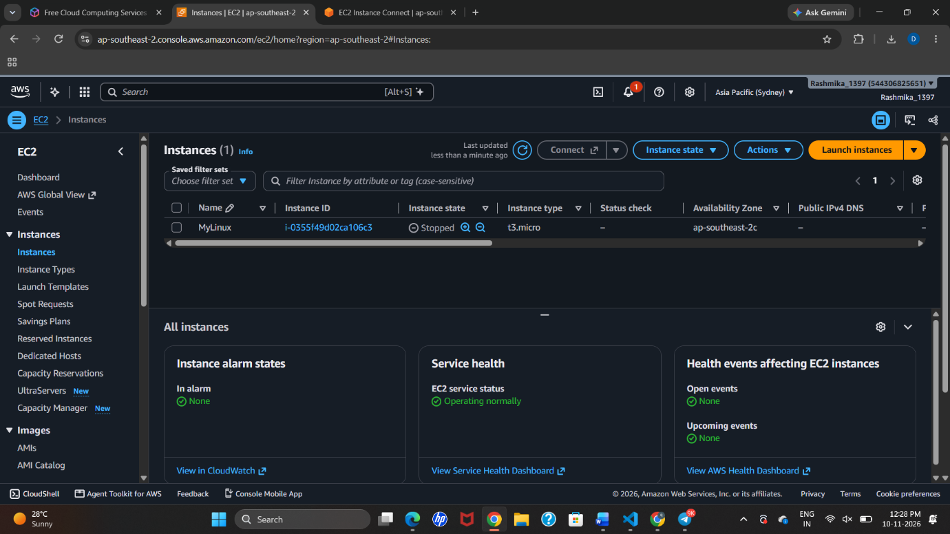

Step 2: Launch an EC2 instance
- Click Launch instances.
- Enter the instance name as MyLinux.
- Select Amazon Linux 2023 as the Amazon Machine Image (AMI).
- Select t3.micro as the instance type.
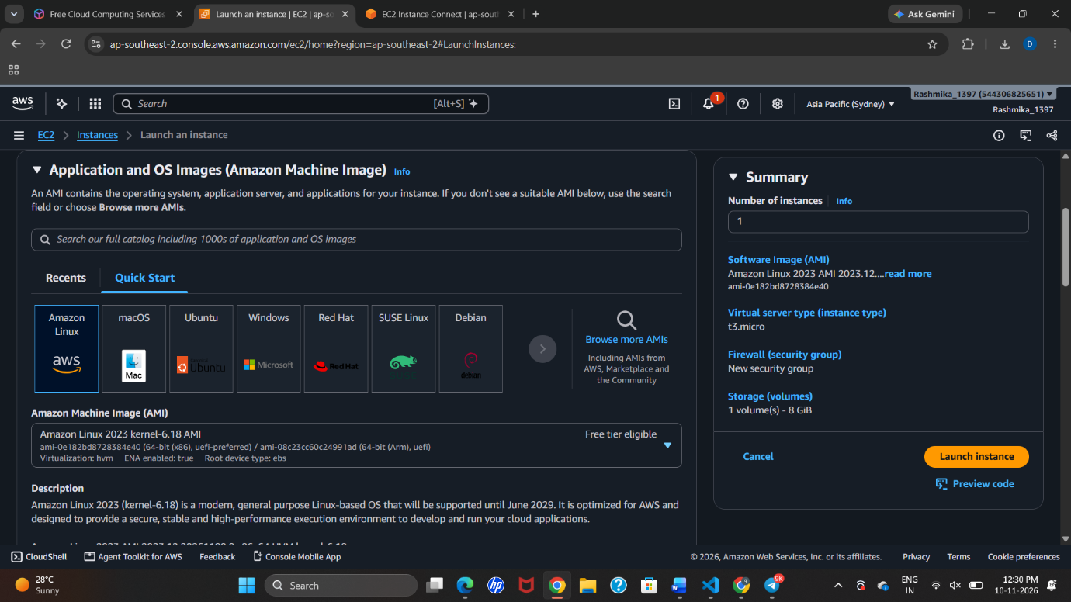
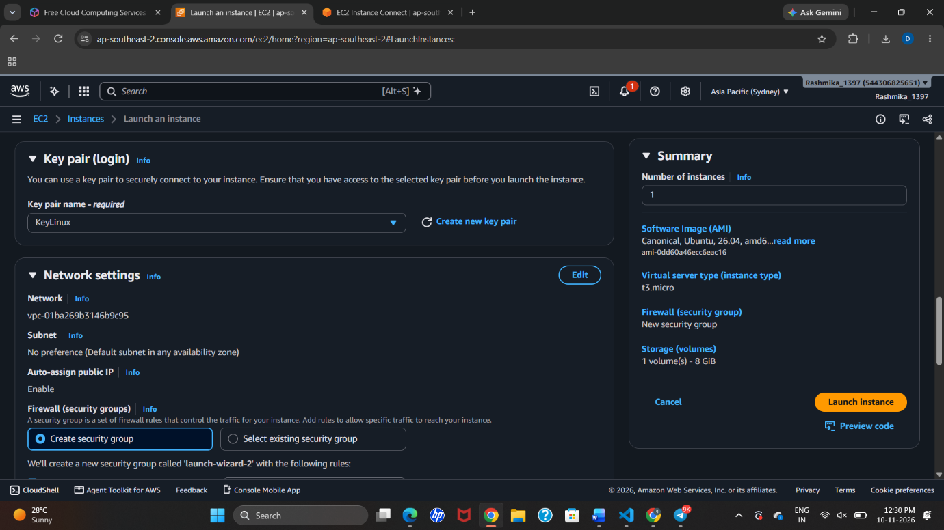

Step 3: Create a key pair
- Open the Key pair (login) section.
- Click Create new key pair.
- Enter the key pair name as Key1.
- Select RSA and the .pem private-key format.
- Create and download the key file. Store it securely; it is used for authentication.
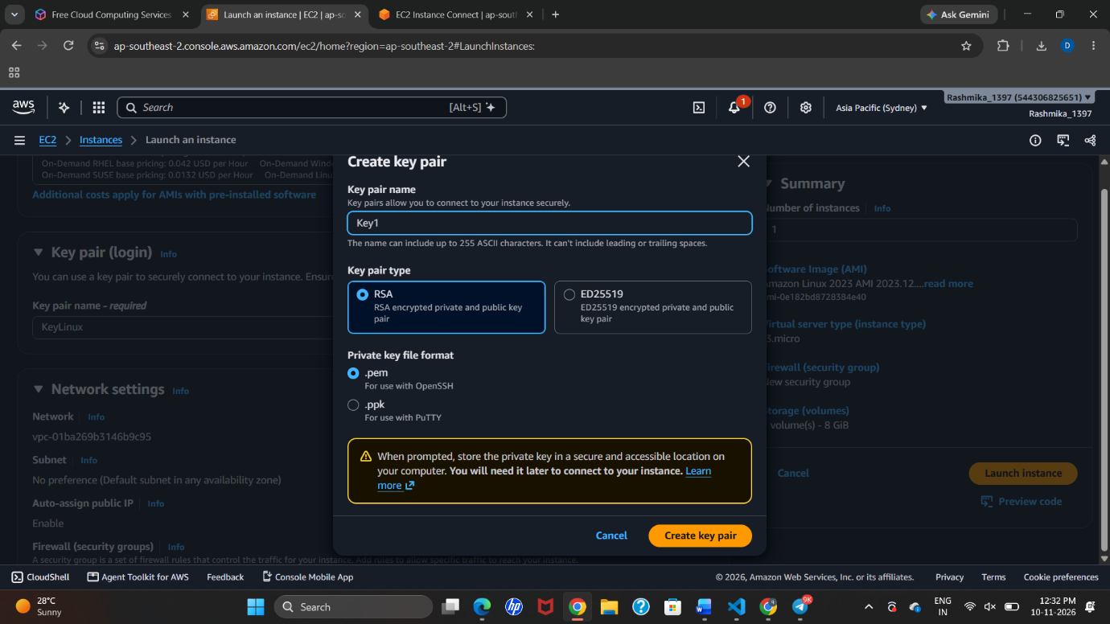

Step 4: Configure network settings
- Use the default VPC and subnet settings shown in the practical.
- Enable Auto-assign public IP.
- Create or select a security group.
- Allow SSH traffic on TCP port 22 for remote terminal access. Restrict the source to your IP address where possible.
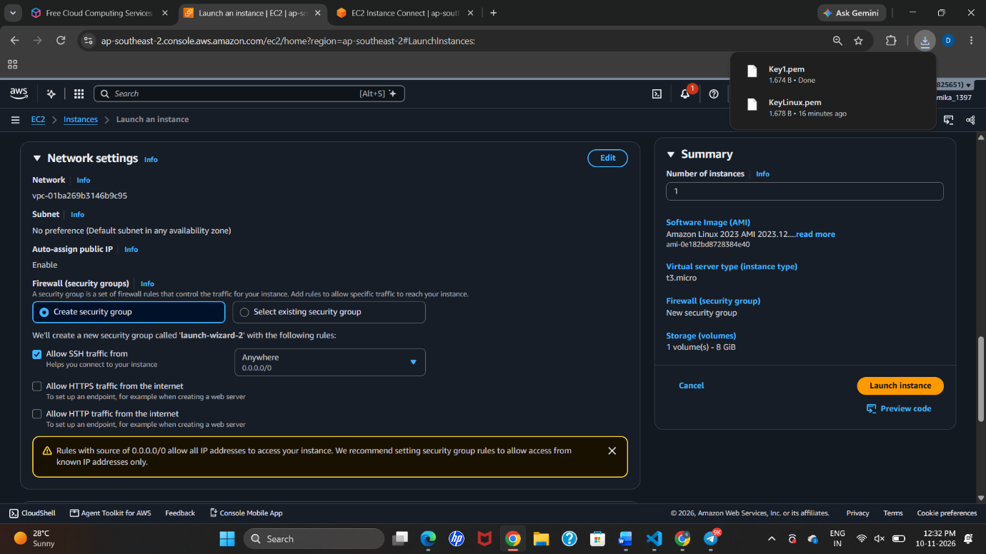

Step 5: Launch the instance
- Review the selected AMI, instance type, key pair, storage, and network settings.
- Click Launch instance.
- Return to the Instances dashboard and wait until the instance state becomes Running.
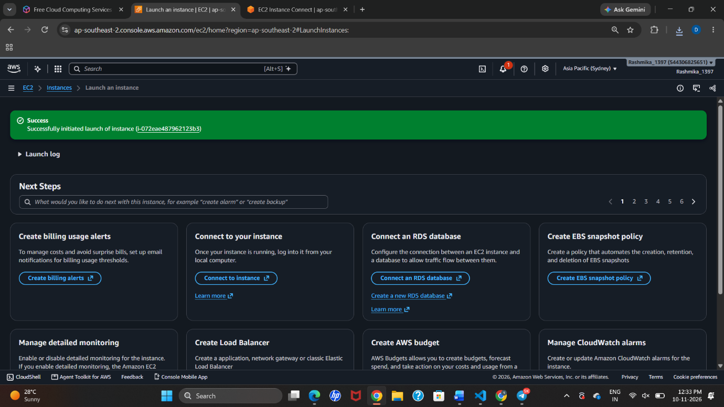

Step 6: Connect to the Linux instance
- Select the MyLinux instance.
- Click Connect.
- Select EC2 Instance Connect.
- Click Connect to open the browser-based terminal.
- The Amazon Linux command-line interface is displayed.
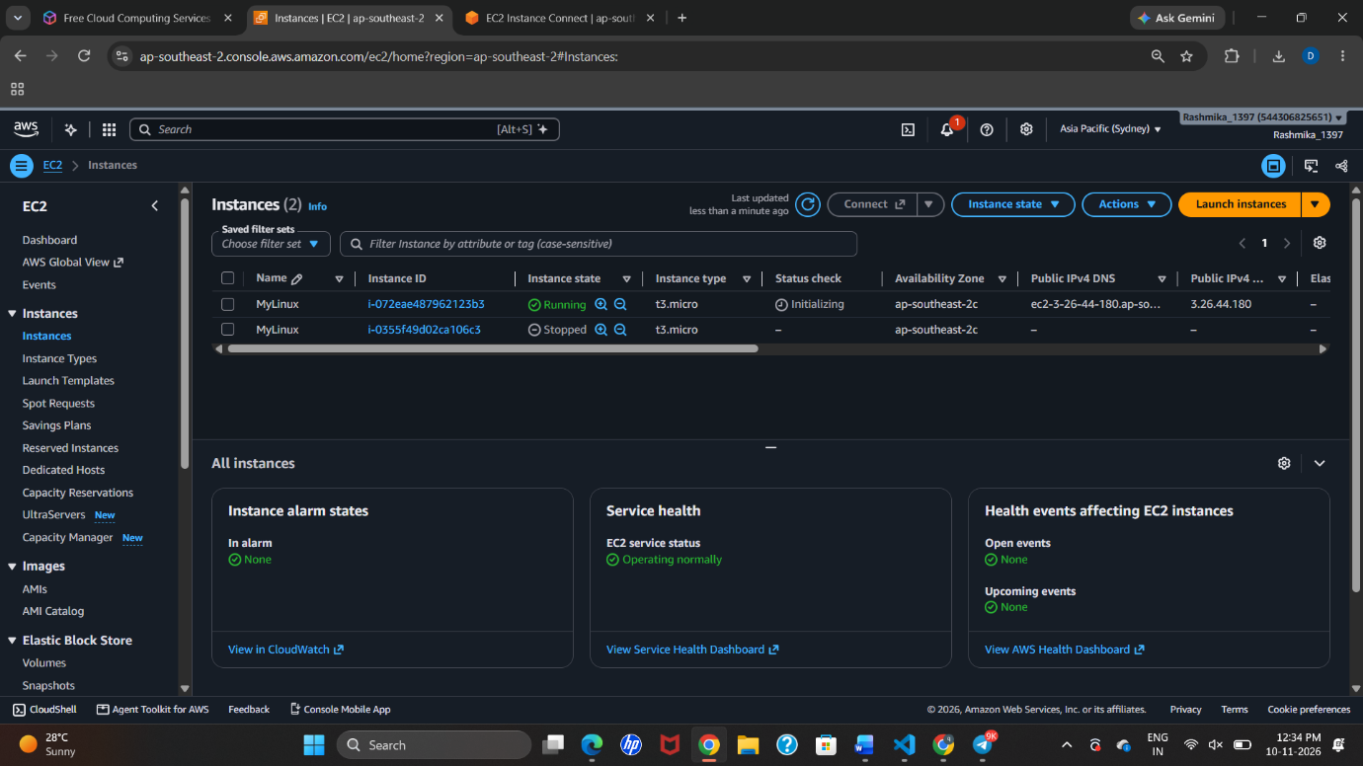
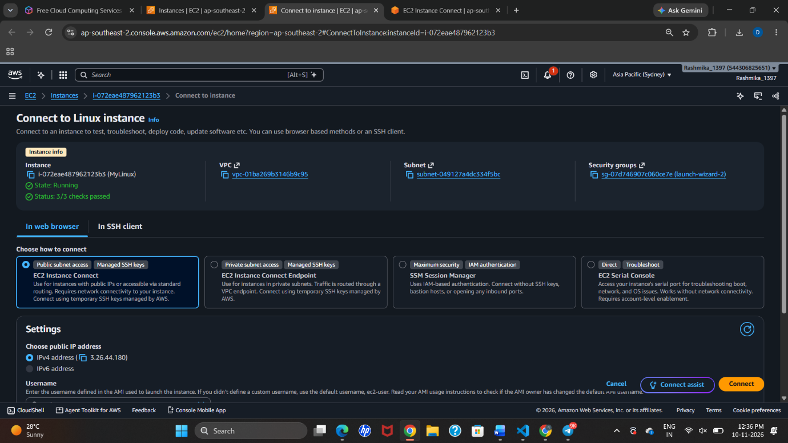

Step 7: Create a directory
Run the following command to create a directory named CIS_practical:
mkdir CIS_practical
Move into the newly created directory:
cd CIS_practical
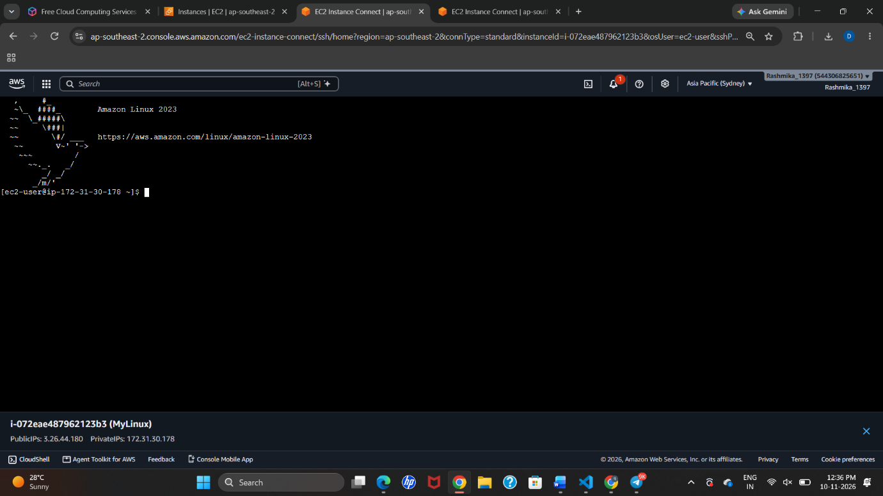

Step 8: Create a text file
Run the Nano text editor command:
- Enter the message shown below in the editor.
- Save using Ctrl + O, press Enter, and exit Nano using Ctrl + X.
nano demo.txt
Enter this message:
Hello! We successfully create an instance in the EC2
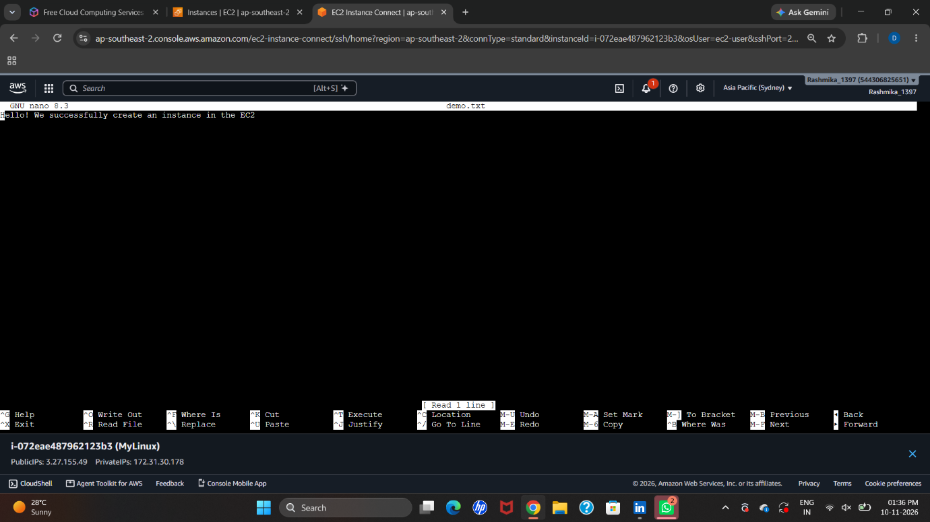

Step 9: Verify the file
- Run the following command to display the contents of the file.
- The message entered in Nano should be displayed, confirming that the file was saved successfully.
cat demo.txt
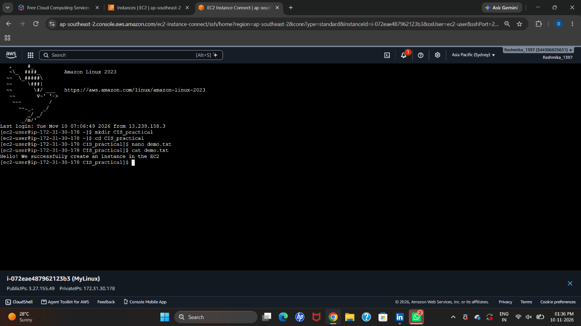

Step 10: Result
The Amazon Linux 2023 EC2 instance was created and launched successfully. The instance was accessed through EC2 Instance Connect, a directory named CIS_practical was created, and a text file named demo.txt was created and verified using the Linux terminal.

PART B: CREATING A WINDOWS EC2 INSTANCE
The supplied screenshots show a Windows instance named MyWindowsVM, a key pair named windowsKey, and an RDP connection using the Windows Administrator account.

Step 1: Open EC2 and start launching an instance
- Open AWS Management Console and navigate to EC2 → Instances.
- Click Launch instances.
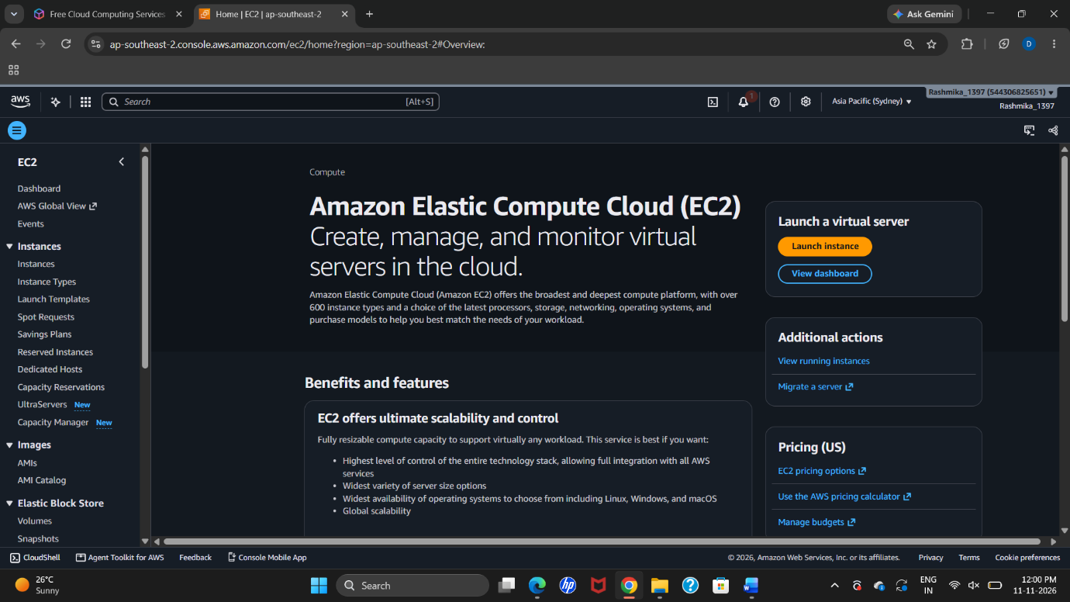
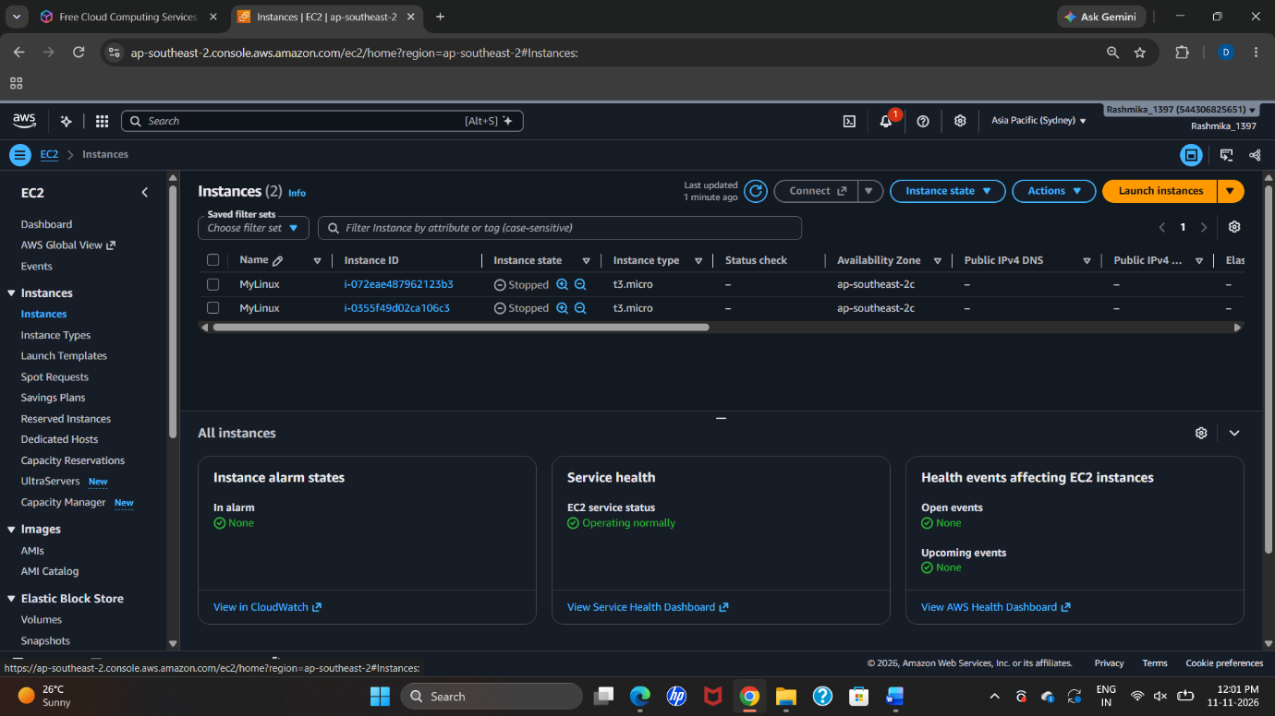

Step 2: Enter the instance name and select Windows
- Enter the instance name as MyWindowsVM.
- Under Application and OS Images (AMI), select a Windows Server AMI from the Windows options. The exact release is not clearly readable in the screenshots.
- Select t3.micro as the instance type.
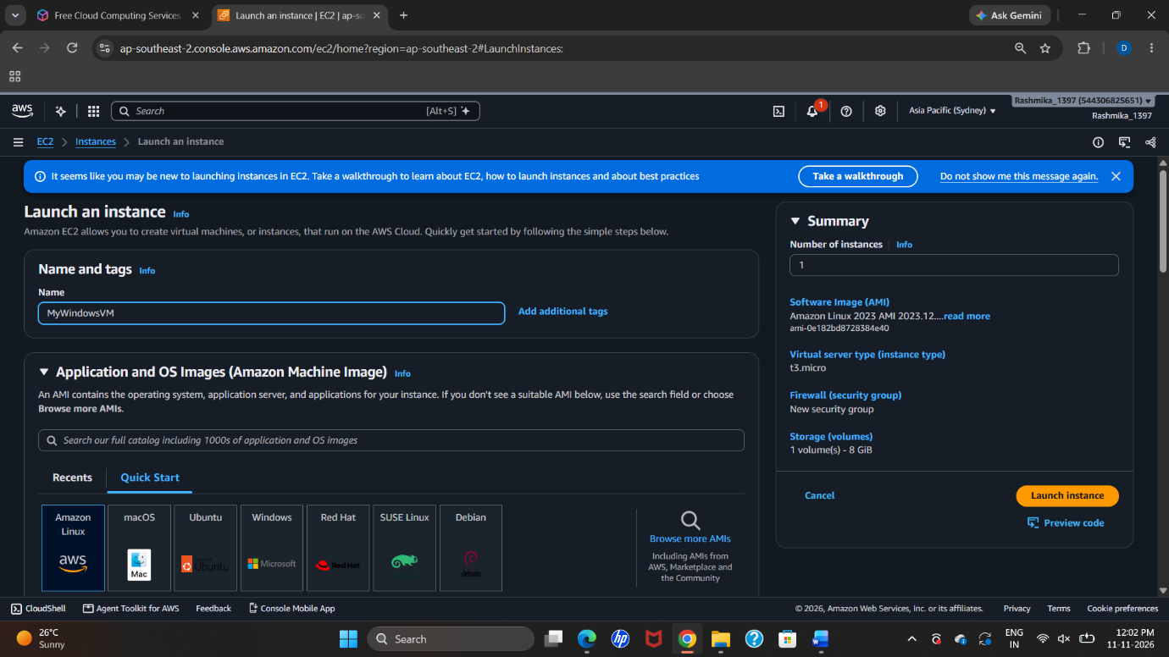
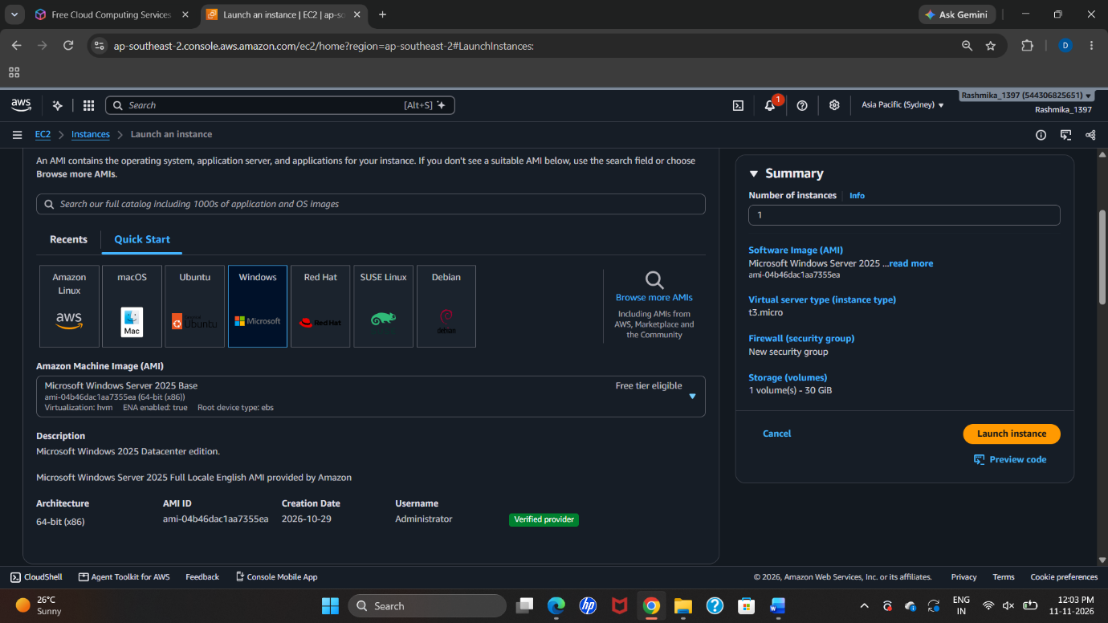
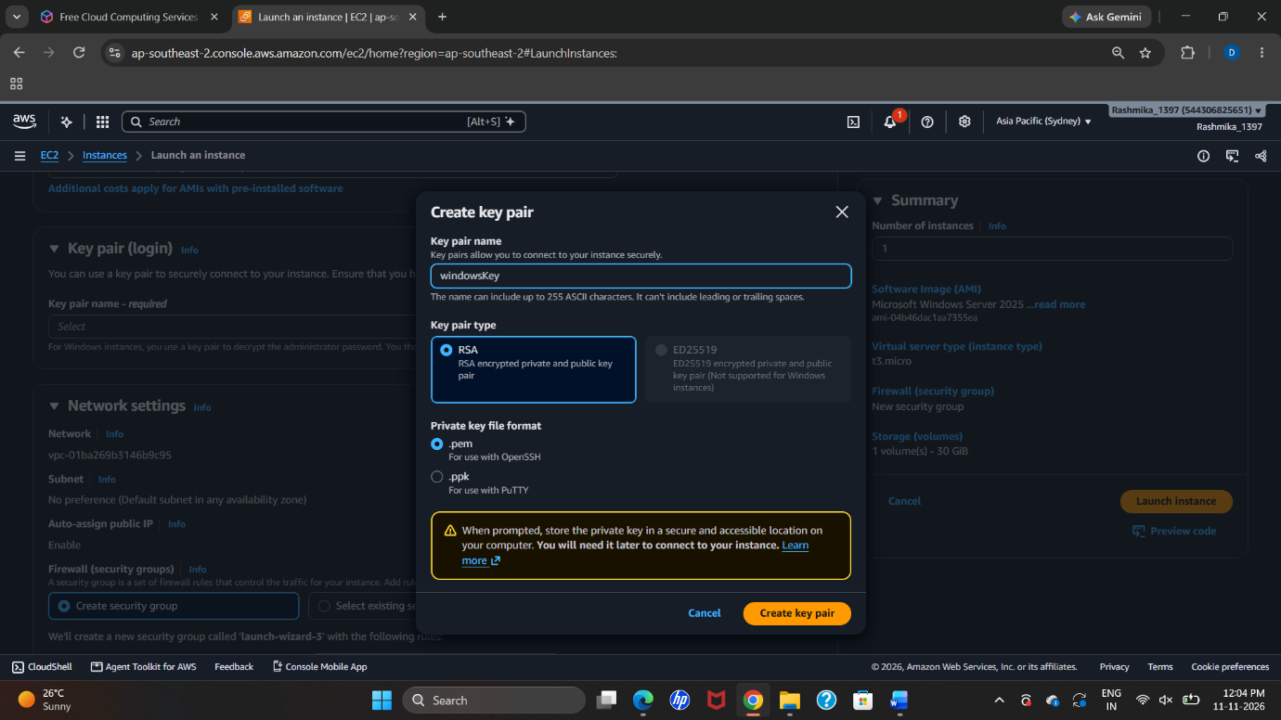
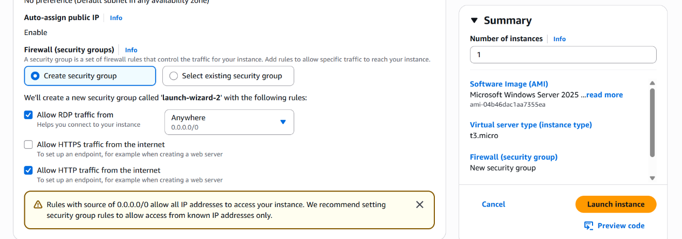

Step 3: Create the Windows key pair
- Open the Key pair (login) section.
- Create or select the key pair named windowsKey (the screenshot displays the associated key pair as windowskey).
- Download the private key file and keep it secure. AWS uses this key to decrypt the initial Windows Administrator password.
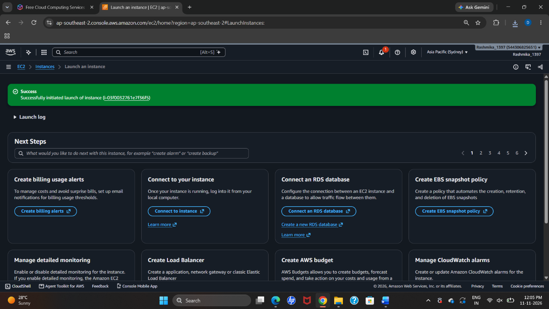
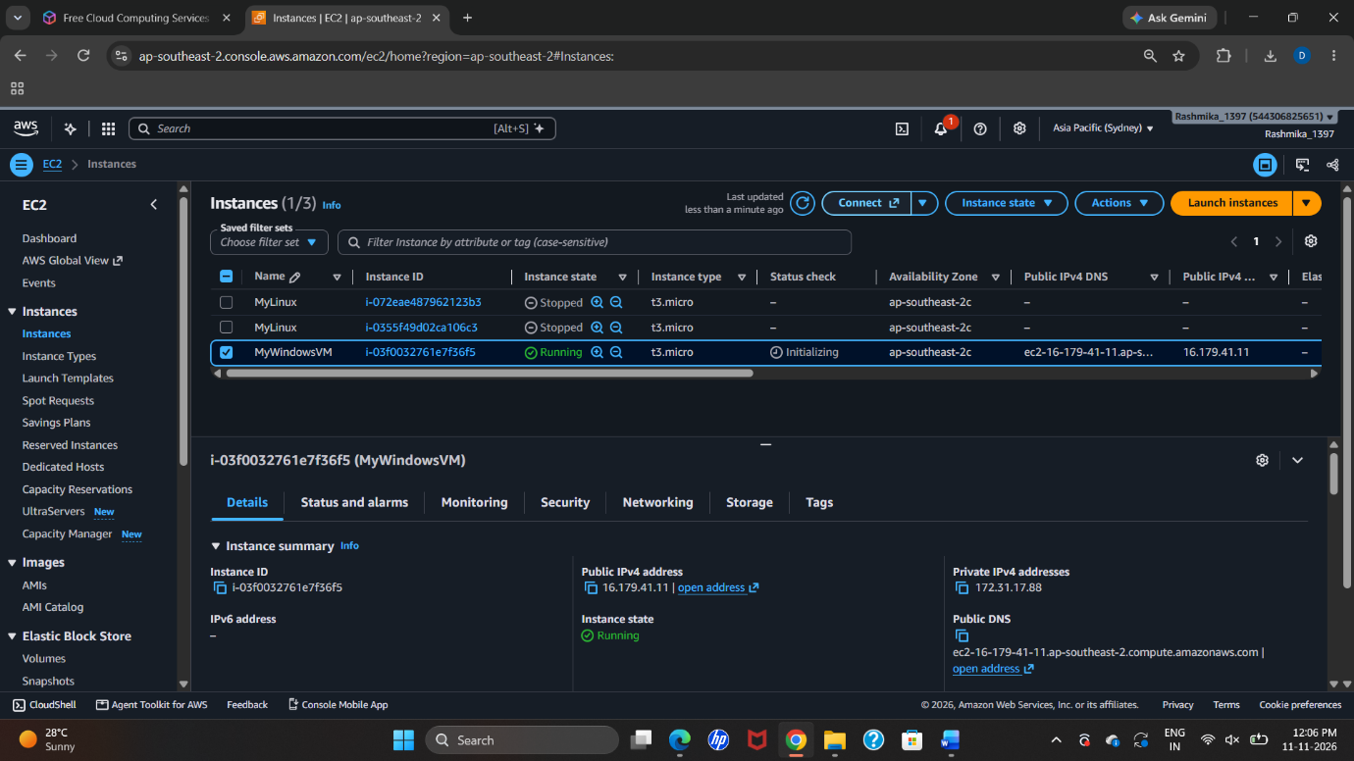

Step 4: Configure network and security group
- Configure the VPC and subnet settings.
- Add an inbound rule for RDP (TCP port 3389) and set the source to My IP, as shown.
- The screenshots also show an SSH (TCP port 22) rule. RDP is the rule required for the Remote Desktop connection; do not open extra ports unless needed.
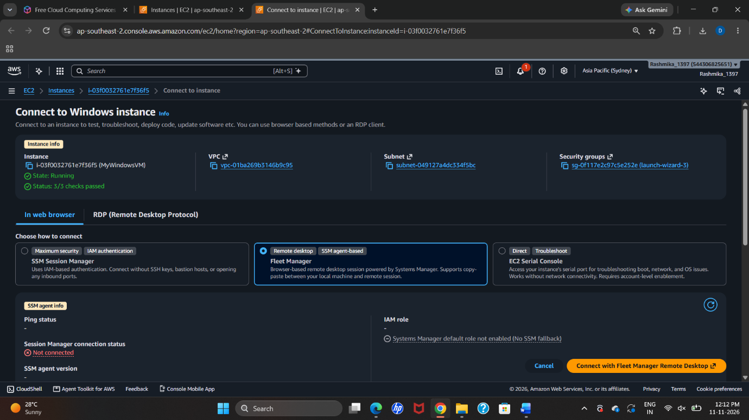

Step 5: Launch the Windows instance
- Review the configuration and click Launch instance.
- Return to Instances and wait until MyWindowsVM shows Running and its status checks pass.
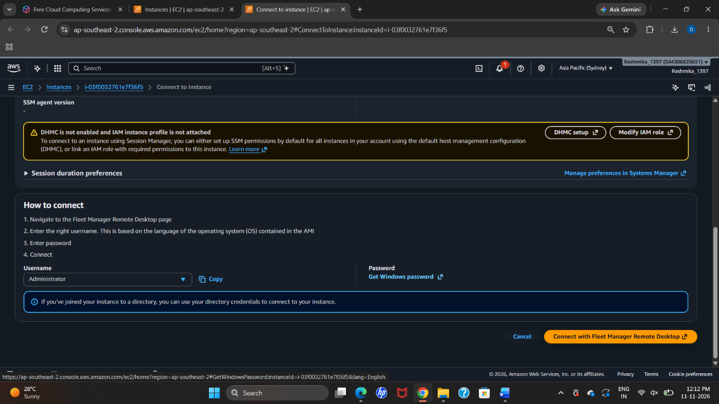
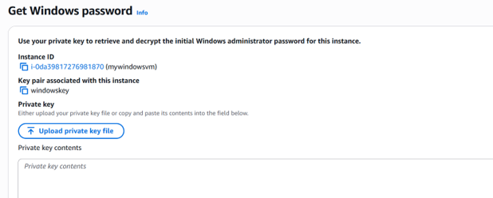

Step 6: Open the Windows connection instructions
- Select MyWindowsVM and click Connect.
- Select the RDP tab.
- Note the public DNS/IP address and username Administrator.
- Download the RDP shortcut file if using the shortcut method.
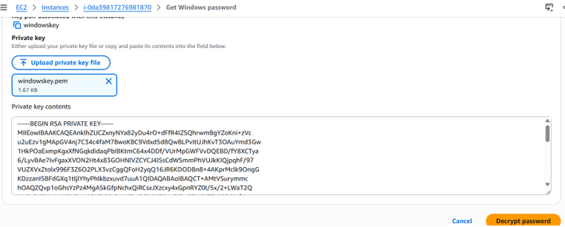
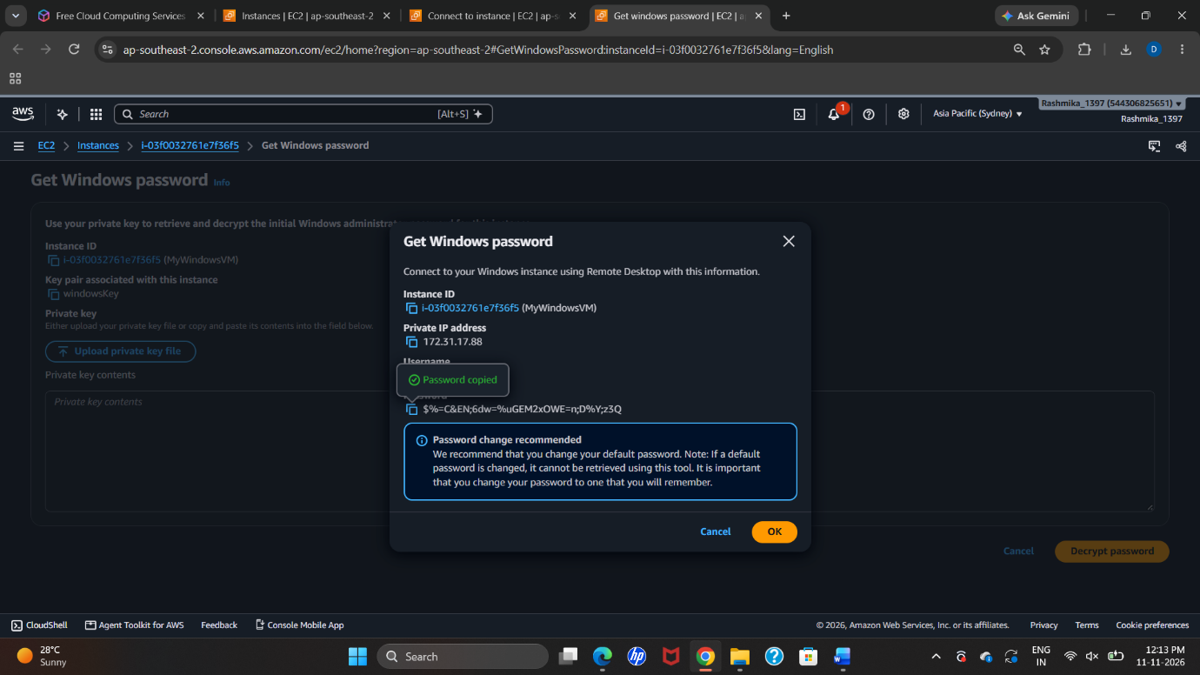
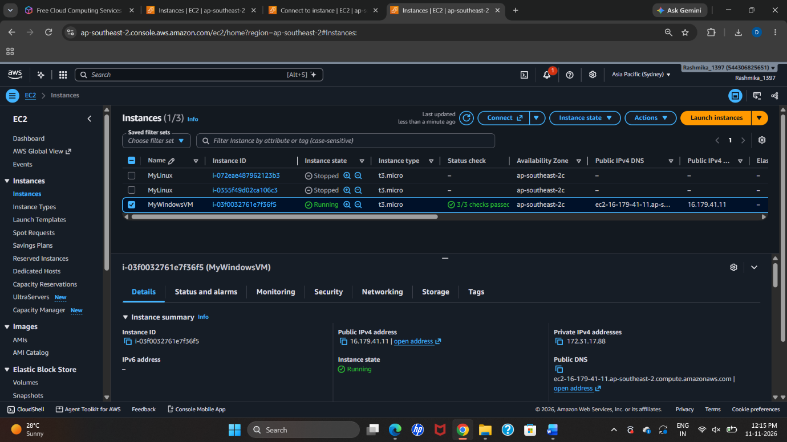

Step 7: Retrieve the Windows Administrator password
- On the EC2 connection page, click Get Windows password.
- Upload the downloaded windowsKey.pem private key file (or paste its contents if requested).
- Click Decrypt password.
- Copy the generated Administrator password and keep it private. Do not include the password or private-key contents in the practical record.
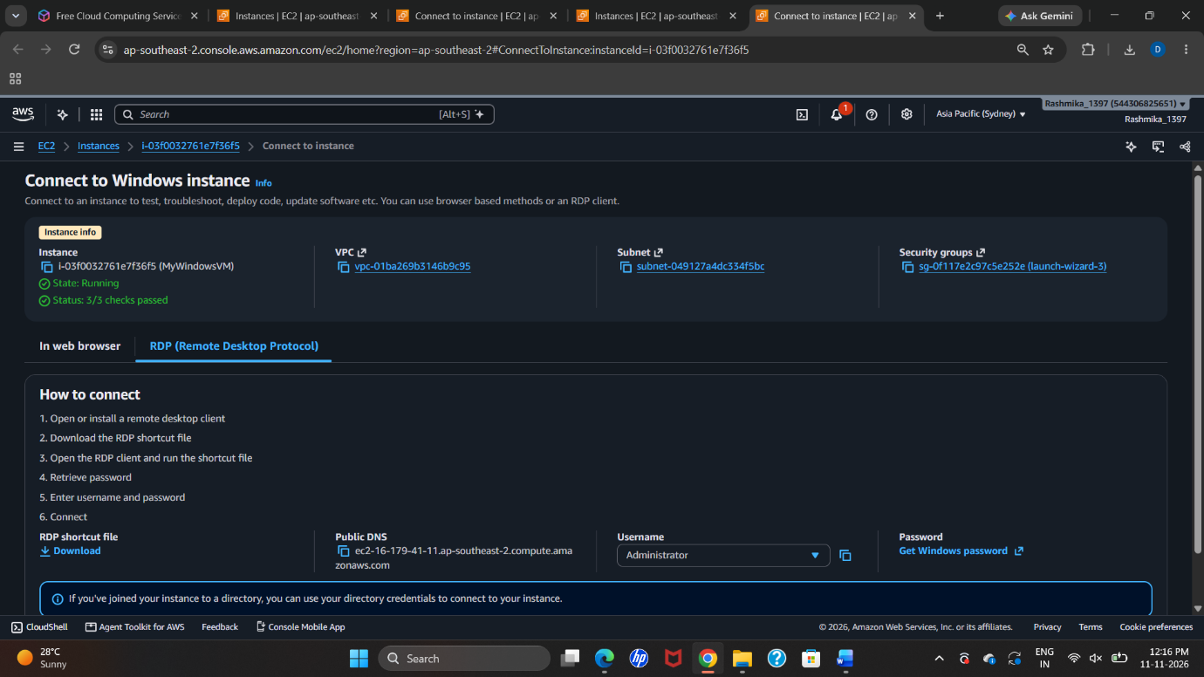
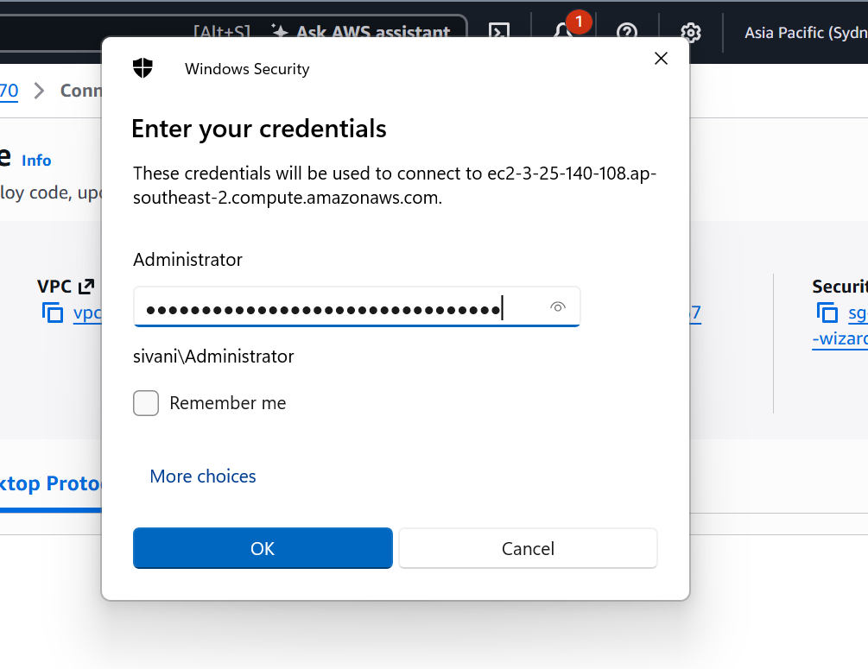

Step 8: Connect using Remote Desktop
- On the Windows computer, open Remote Desktop Connection.
- Enter the public DNS name or public IP address of the EC2 Windows instance.
- Enter username Administrator and the decrypted password.
- If a certificate identity warning appears, verify the EC2 instance before proceeding.
- Complete the connection and wait for the remote Windows desktop to load.
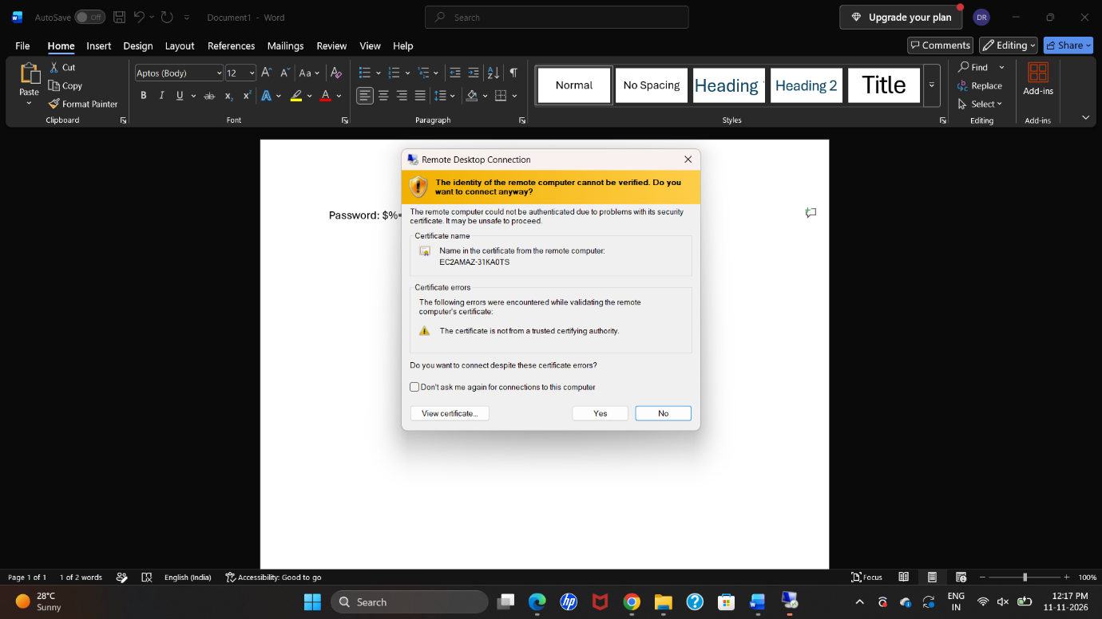
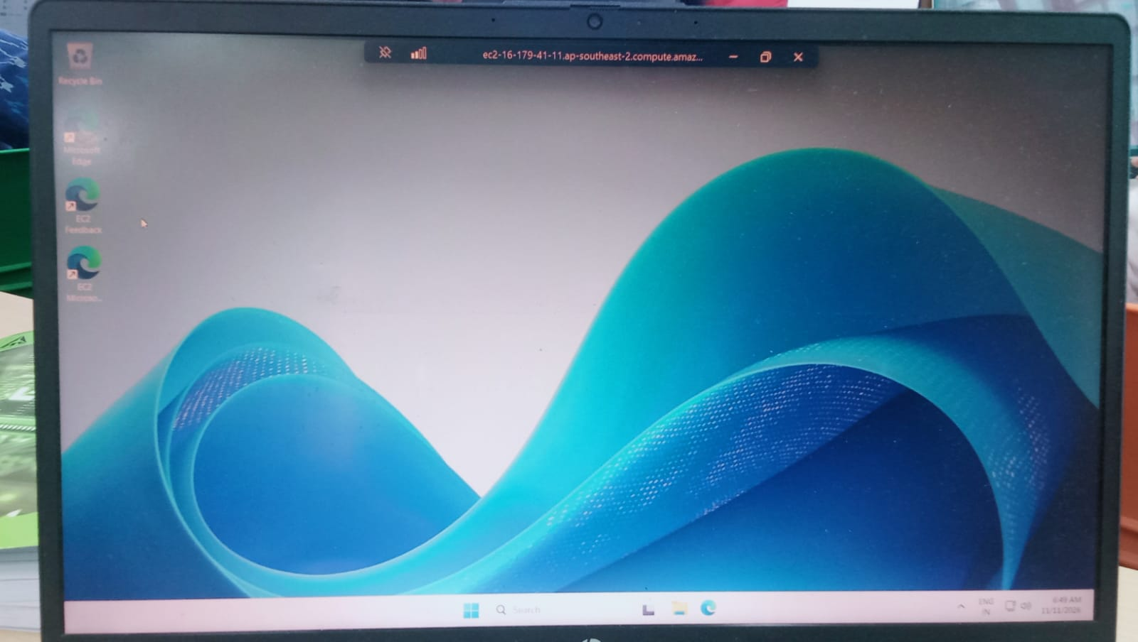

Step 9: Result
The Windows EC2 instance named MyWindowsVM was launched successfully. Its initial Administrator password was retrieved using the associated private key, and the instance was accessed through Remote Desktop Protocol (RDP).
Security reminder: Never share the .pem key, decrypted Administrator password, or any password placed in user data. If a real password was exposed in a screenshot or shared document, change it immediately.

PART C: CREATING AN UBUNTU EC2 INSTANCE
The Ubuntu screenshots show an instance named LinuxUOI, Ubuntu Server 26.04 LTS, instance type t3.small, an 8 GiB root volume, and a key pair named guikey. A user-data script was entered to install a desktop environment and XRDP for remote desktop access.

Step 1: Start launching an EC2 instance
- Open EC2 → Instances in the AWS Management Console.
- Click Launch instances.
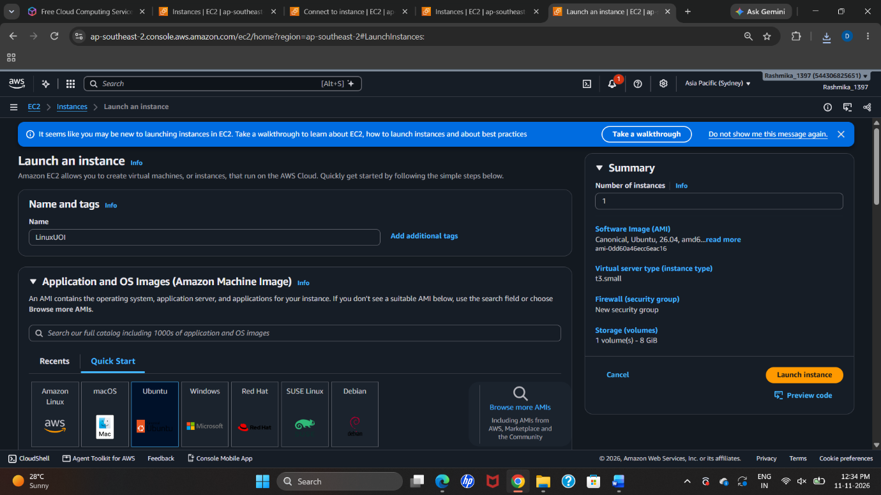

Step 2: Enter the instance name and select Ubuntu
- Enter the instance name as LinuxUOI.
- Under Application and OS Images (AMI), select Ubuntu.
- The screenshot shows Ubuntu Server 26.04 LTS as the selected AMI.
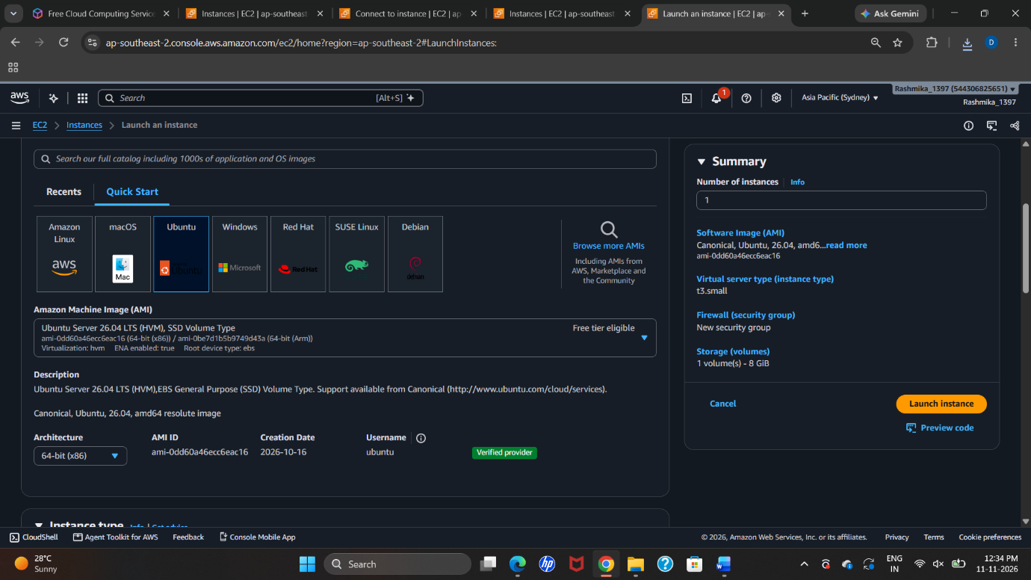
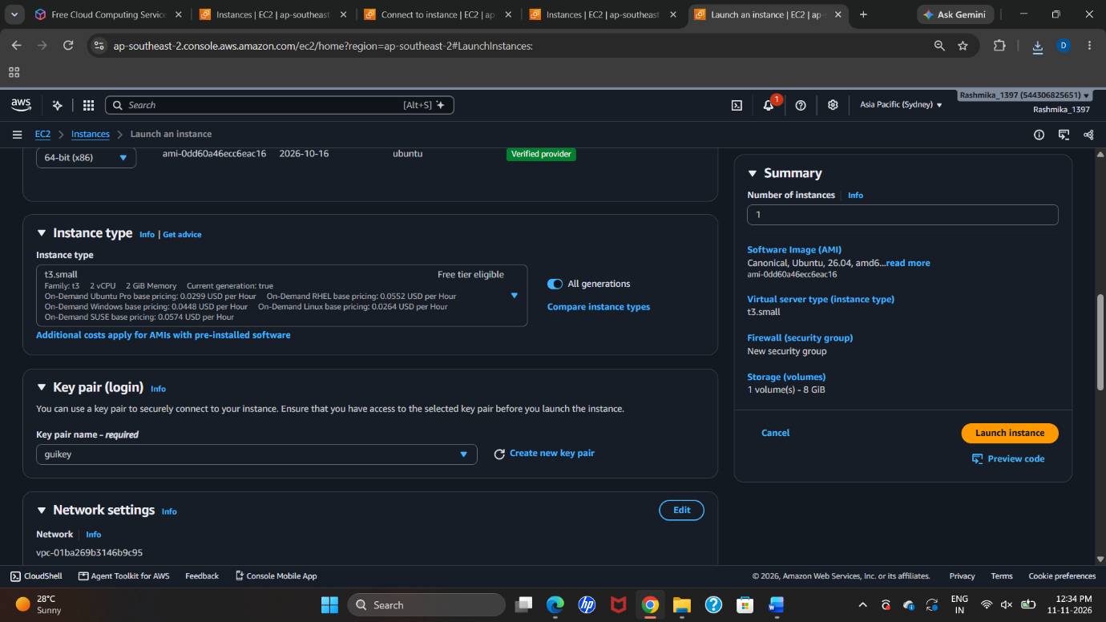

Step 3: Select the instance type and key pair
- Select t3.small as the instance type.
- In the key pair section, select guikey.
- Ensure that the matching private key is safely available.
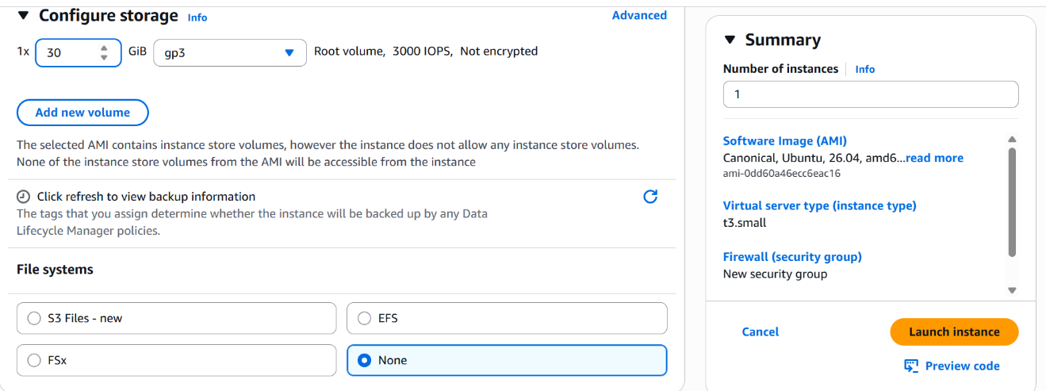

Step 4: Configure storage and network
- Keep the root EBS volume at 8 GiB, as shown in the instance summary.
- Configure the VPC and subnet.
- In the security group, allow required remote-desktop traffic on TCP port 3389 from your own IP. SSH on port 22 may also be allowed if terminal administration is required.
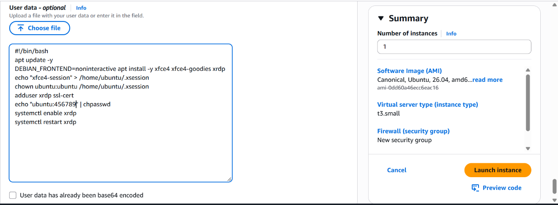
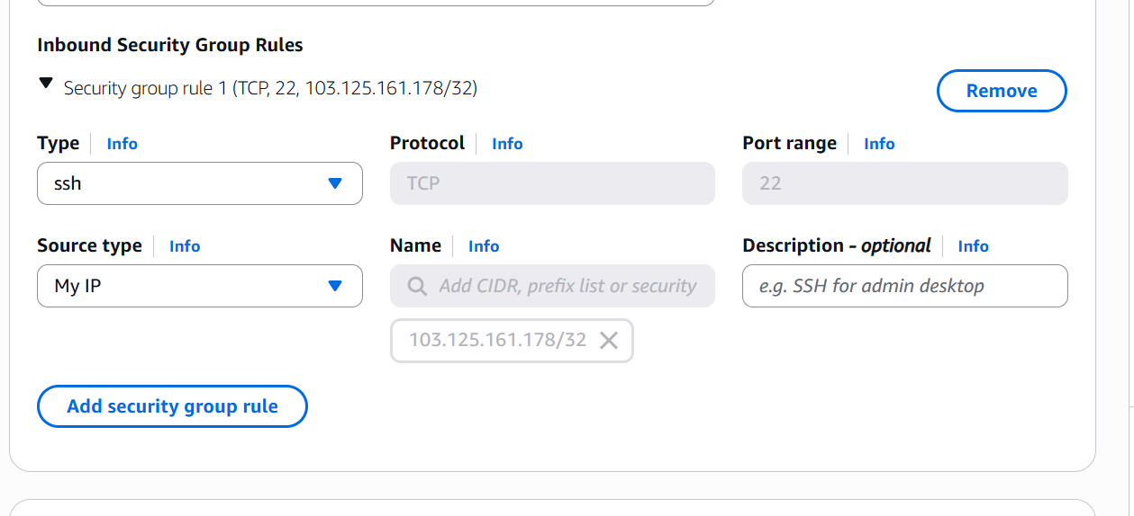
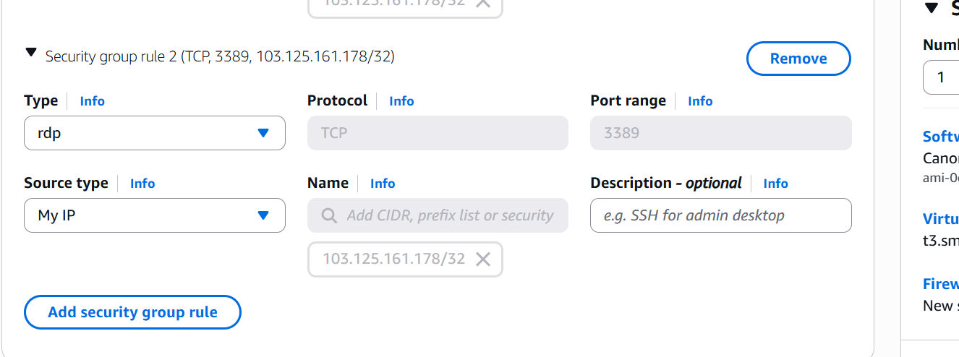

Step 5: Add the user-data startup script
- Open Advanced details → User data.
- Paste the following startup script. Replace the password placeholder with a new strong password before launching.
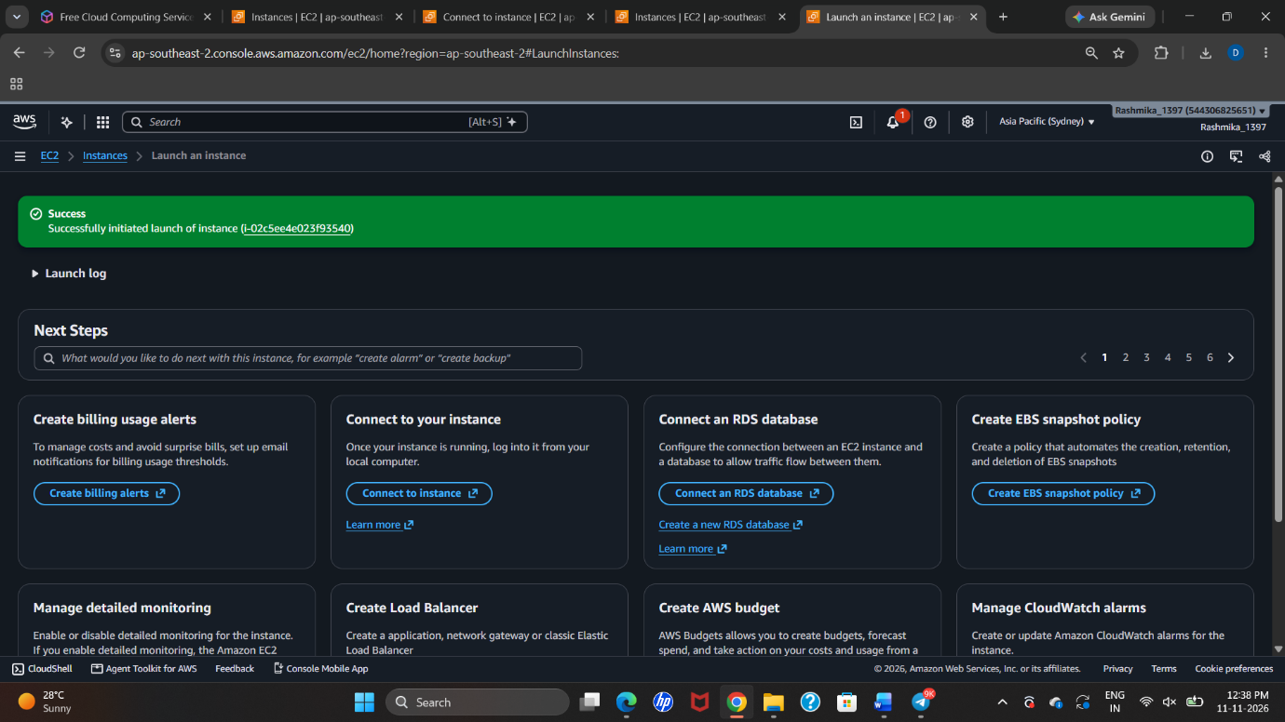
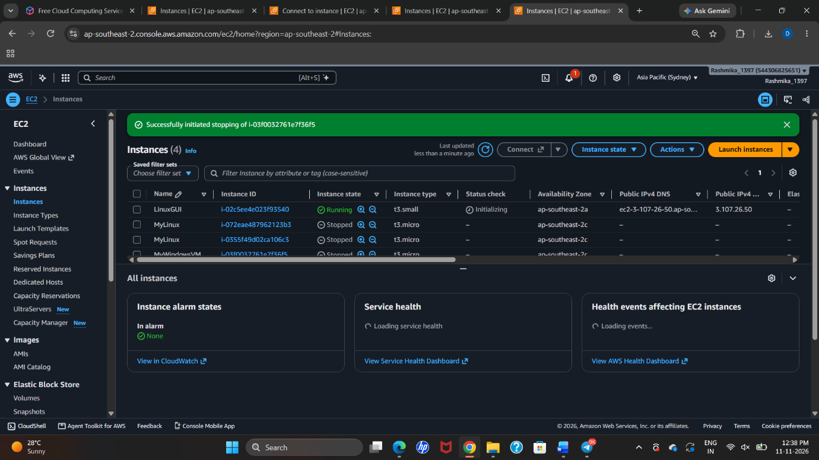
#!/bin/bash
apt update -y
DEBIAN_FRONTEND=noninteractive apt install -y xfce4 xfce4-goodies xrdp
echo "xfce4-session" > /home/ubuntu/.xsession
chown ubuntu:ubuntu /home/ubuntu/.xsession
adduser xrdp ssl-cert
echo 'ubuntu:CHANGE_TO_A_STRONG_PASSWORD' | chpasswd
systemctl enable xrdp
systemctl restart xrdp
The script updates Ubuntu, installs the XFCE desktop environment and XRDP, configures the Ubuntu user's desktop session, and enables the XRDP service. The password visible in the original screenshot is intentionally not reproduced.
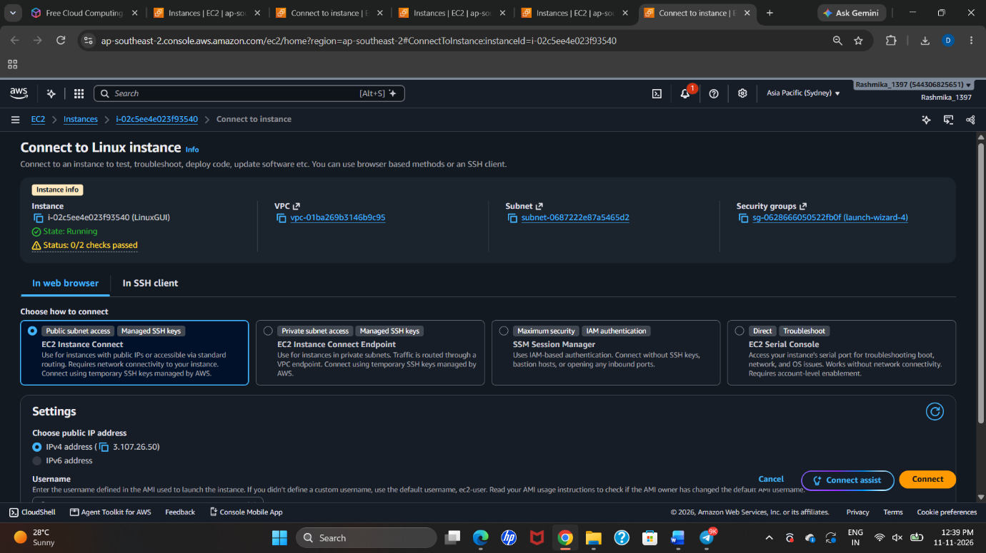
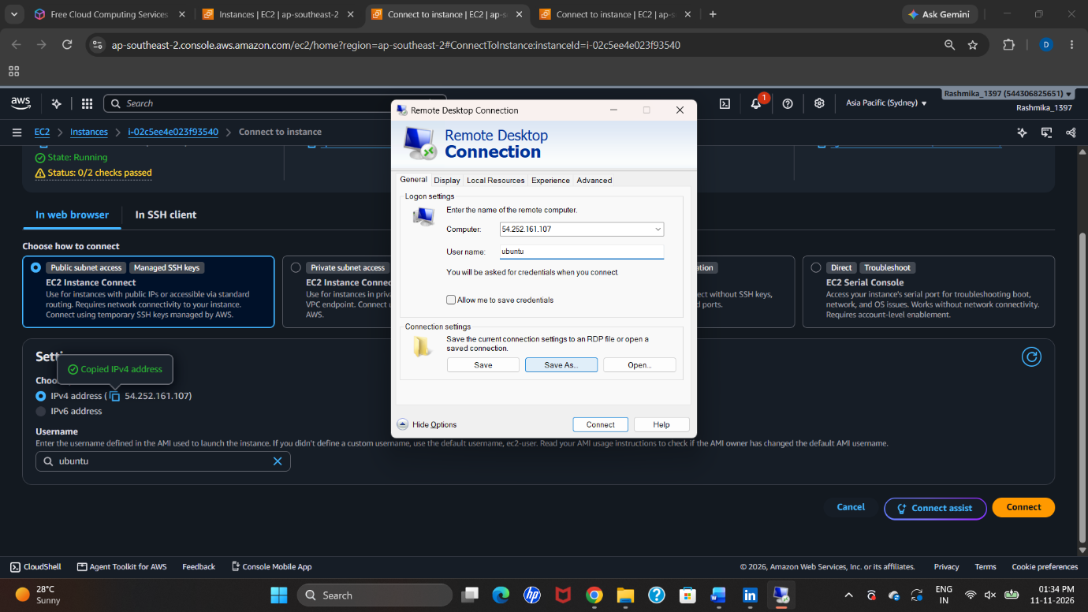
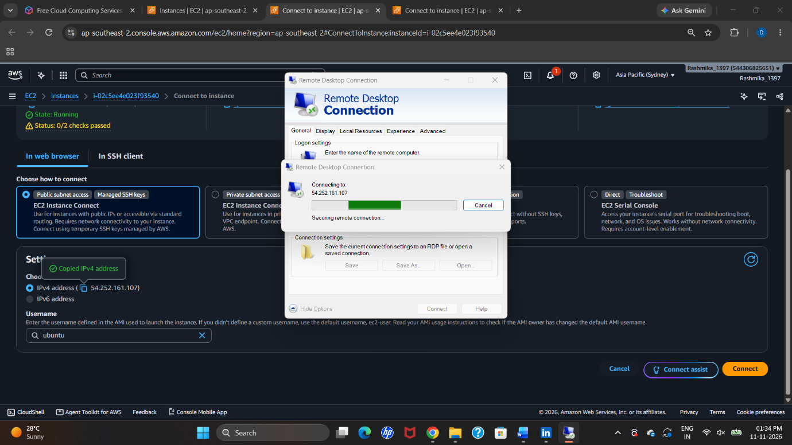
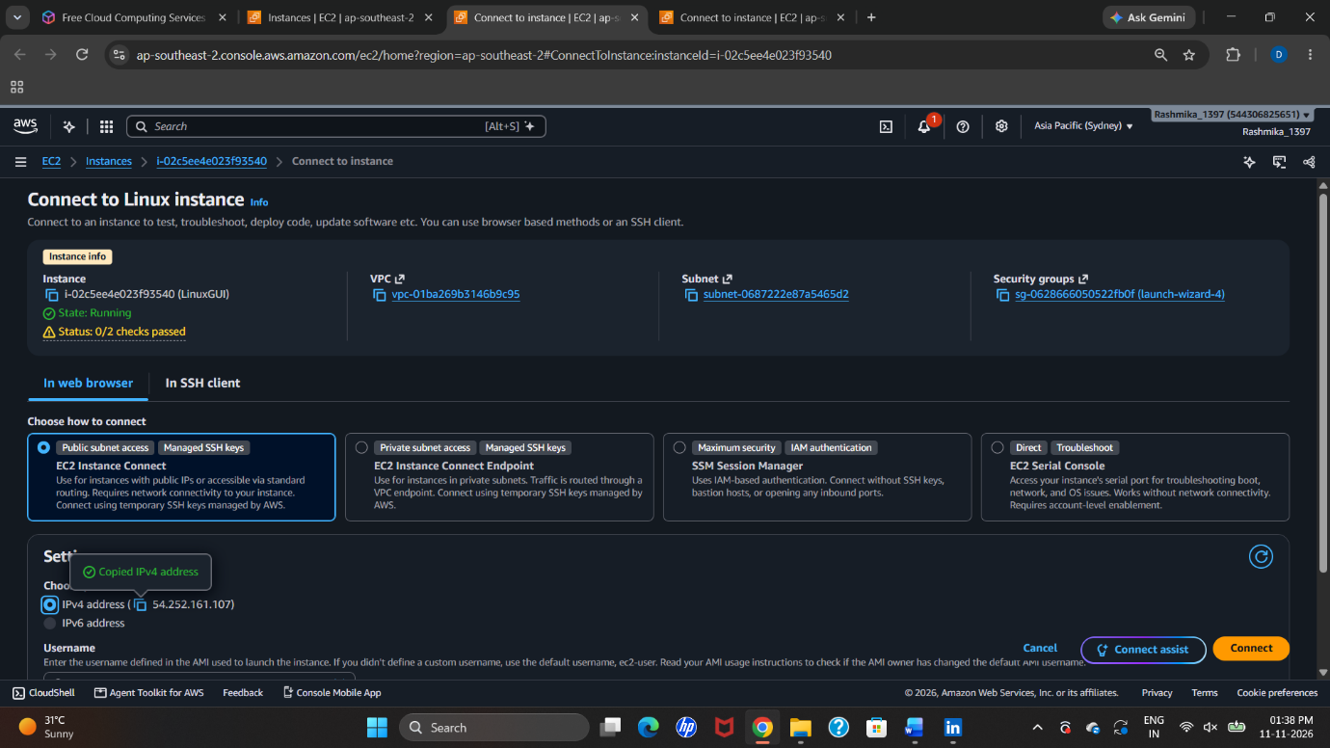

Step 6: Launch the Ubuntu instance
- Review the AMI, instance type, key pair, storage, network rules, and user data.
- Click Launch instance.
- Wait for the instance state to become Running and allow a few minutes for the first-boot installation script to complete.

Step 7: Connect to the Ubuntu desktop using RDP
- Copy the Ubuntu instance's public IPv4 address from the EC2 Instances page.
- Open Remote Desktop Connection on your computer.
- Enter the Ubuntu instance's public IP address.
- Connect using username ubuntu and the password configured in the user-data script.
- After authentication, the XFCE desktop session should open.

Step 8: Result
The Ubuntu EC2 instance named LinuxUOI was configured and launched. The startup script was used to install the XFCE desktop environment and XRDP, enabling remote desktop access to the Ubuntu instance.
Important: User data may contain secrets and is not a secure place for long-term password storage. For a real deployment, use a safer credential-management method and rotate any password that was exposed.

PART D: S3 BUCKET CREATION AND UPLOADING OBJECTS
Amazon Simple Storage Service (Amazon S3) is an object-storage service. A bucket is a container in which files (objects) are stored. The screenshots show a bucket named rashmikafiles in the Asia Pacific (Sydney) – ap-southeast-2 region.

Step 1: Open Amazon S3
- Sign in to the AWS Management Console.
- Search for S3 and open Amazon S3.
- On the S3 home page, click Create bucket.
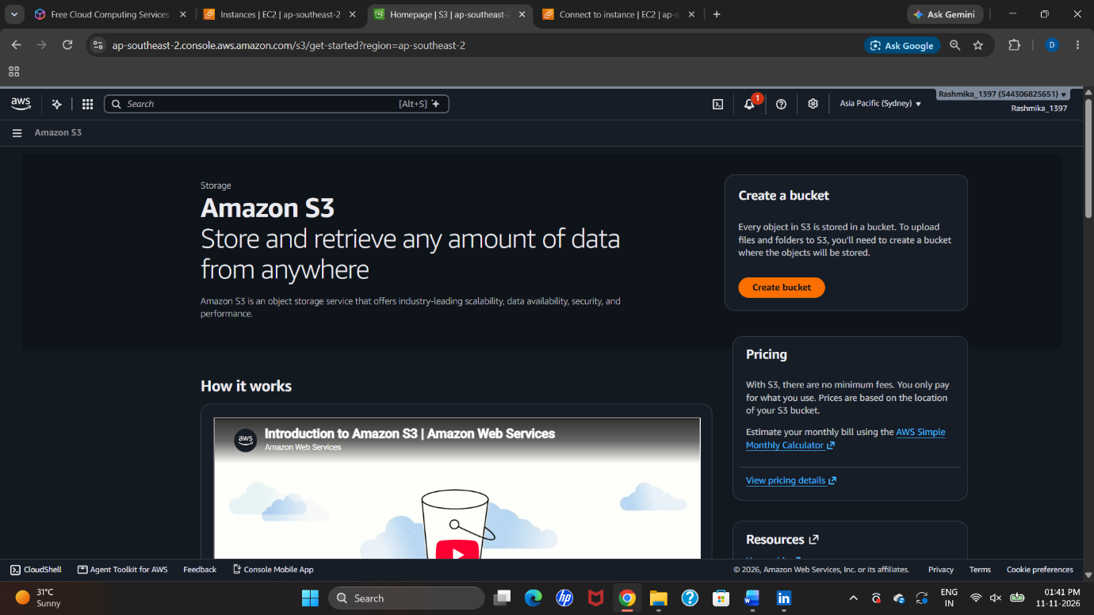

Step 2: Configure the bucket
- Under bucket type, keep General purpose selected.
- Keep the global namespace option selected. Bucket names in this namespace must be globally unique.
- Select Asia Pacific (Sydney) – ap-southeast-2.
- Enter the bucket name as rashmikafiles (the console displays bucket names in lowercase).
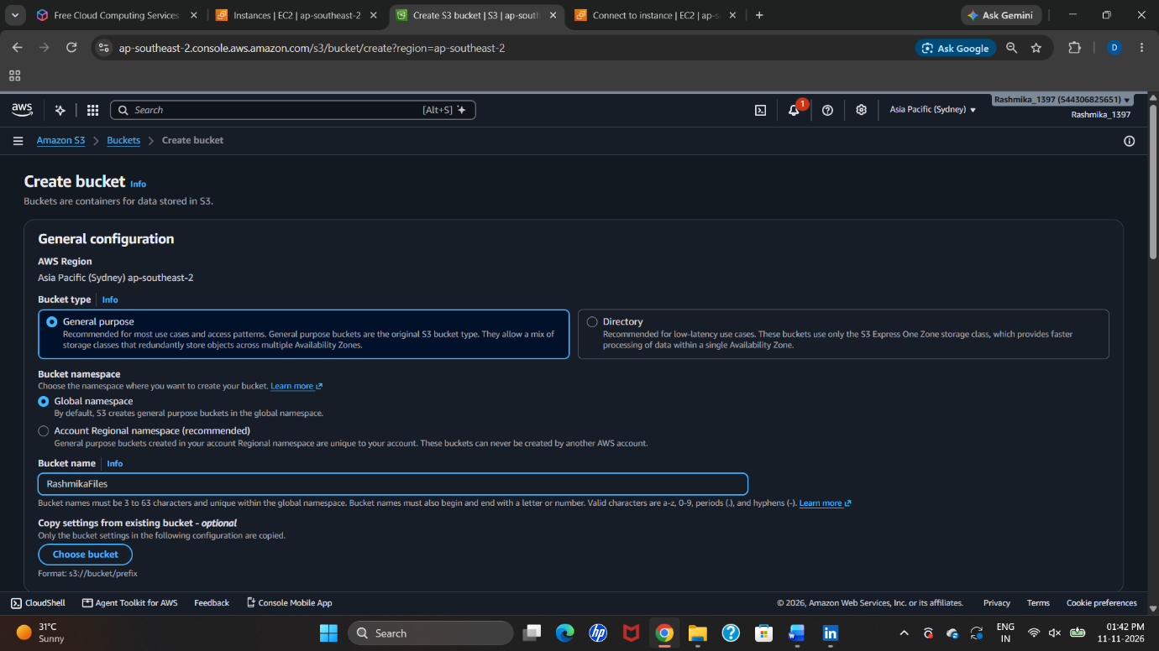

Step 3: Review bucket settings
- Review the remaining bucket settings.
- The screenshot shows default server-side encryption using Amazon S3 managed keys (SSE-S3).
- Keep public access blocked unless the task specifically requires public access. Do not make the bucket public just to upload or view files.
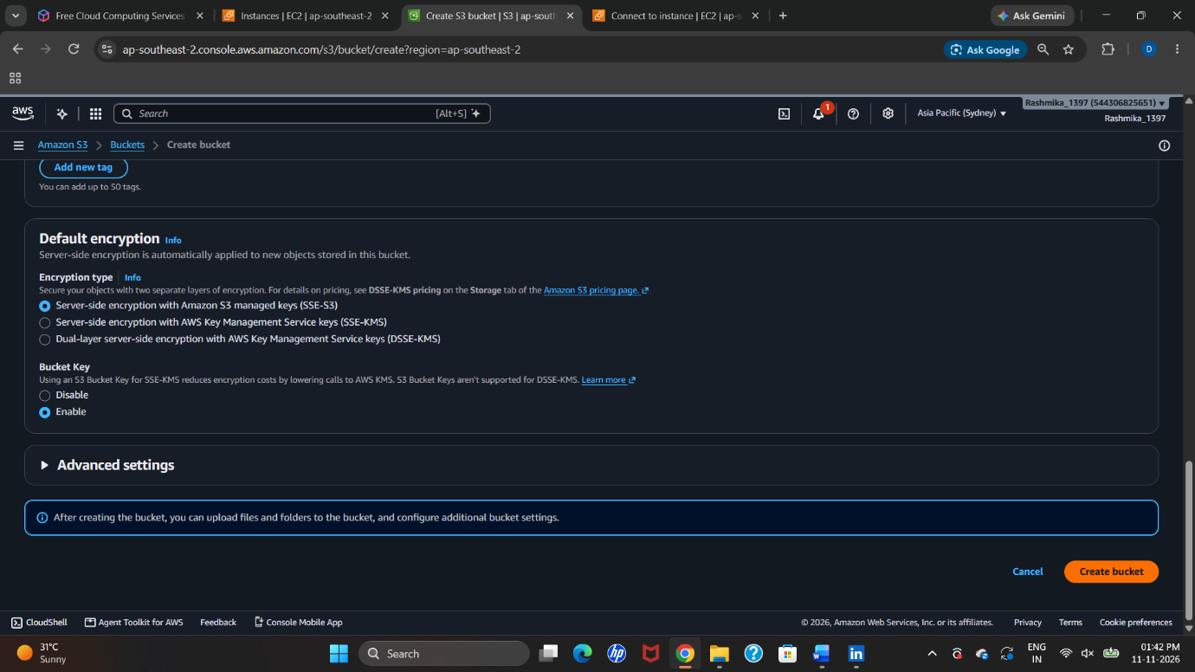

Step 4: Create the bucket
- Scroll to the bottom of the page.
- Click Create bucket.
- AWS displays a success message confirming that the bucket was created.
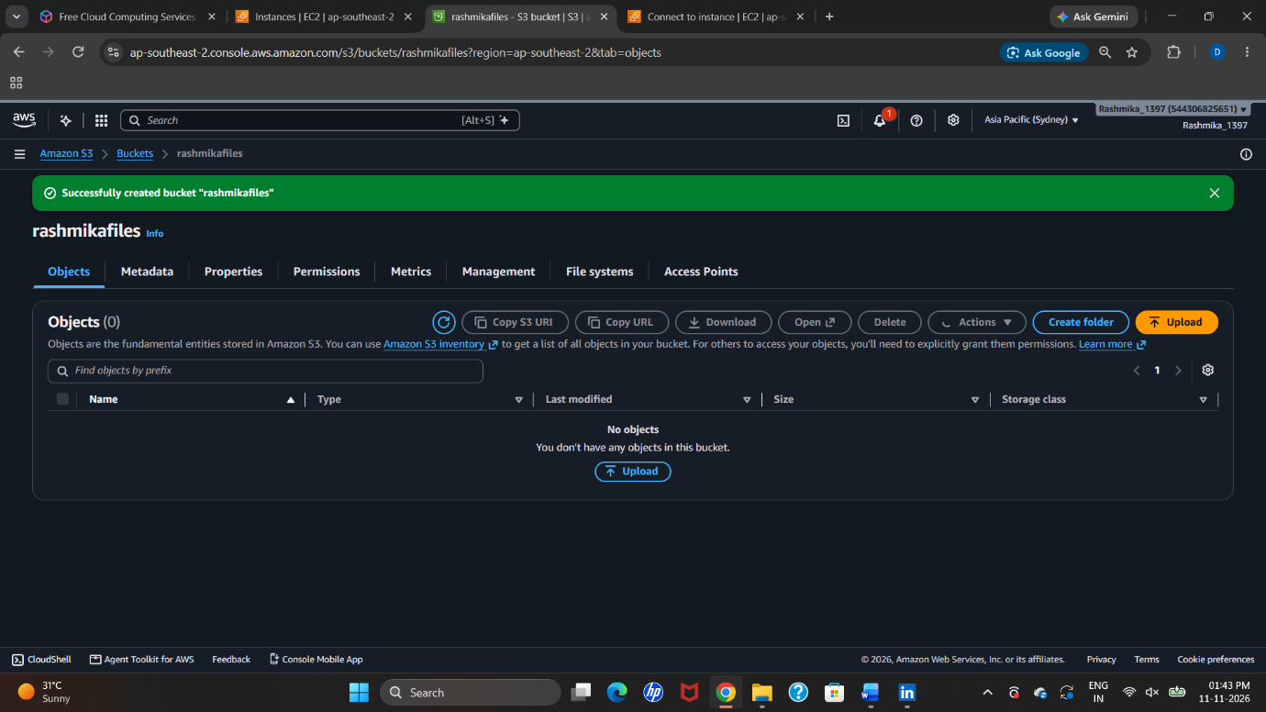

Step 5: Open the bucket and choose Upload
- Open the newly created bucket named rashmikafiles.
- On the Objects tab, click Upload.
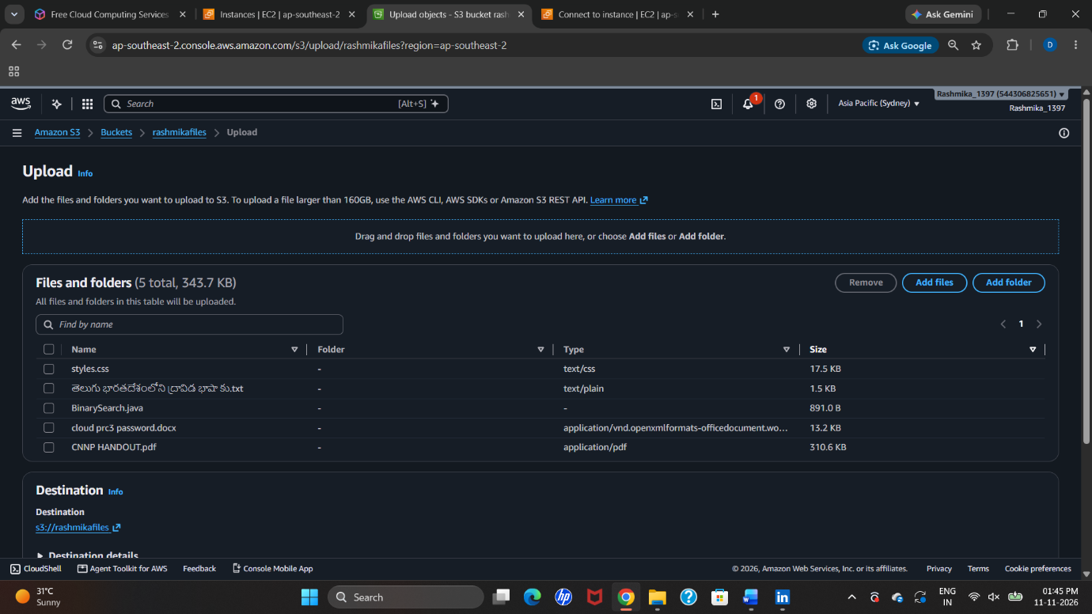

Step 6: Add five objects with different file extensions
- On the Upload page, click Add files.
- Select the five files shown in the practical screenshot: styles.css (.css), a Telugu-language text file (.txt; full filename is truncated), BinarySearch.java (.java), cloud_pr3_password.docx (.docx), and CNNP HANDOUT.pdf (.pdf).
- Confirm that all five files appear in the upload list before proceeding.
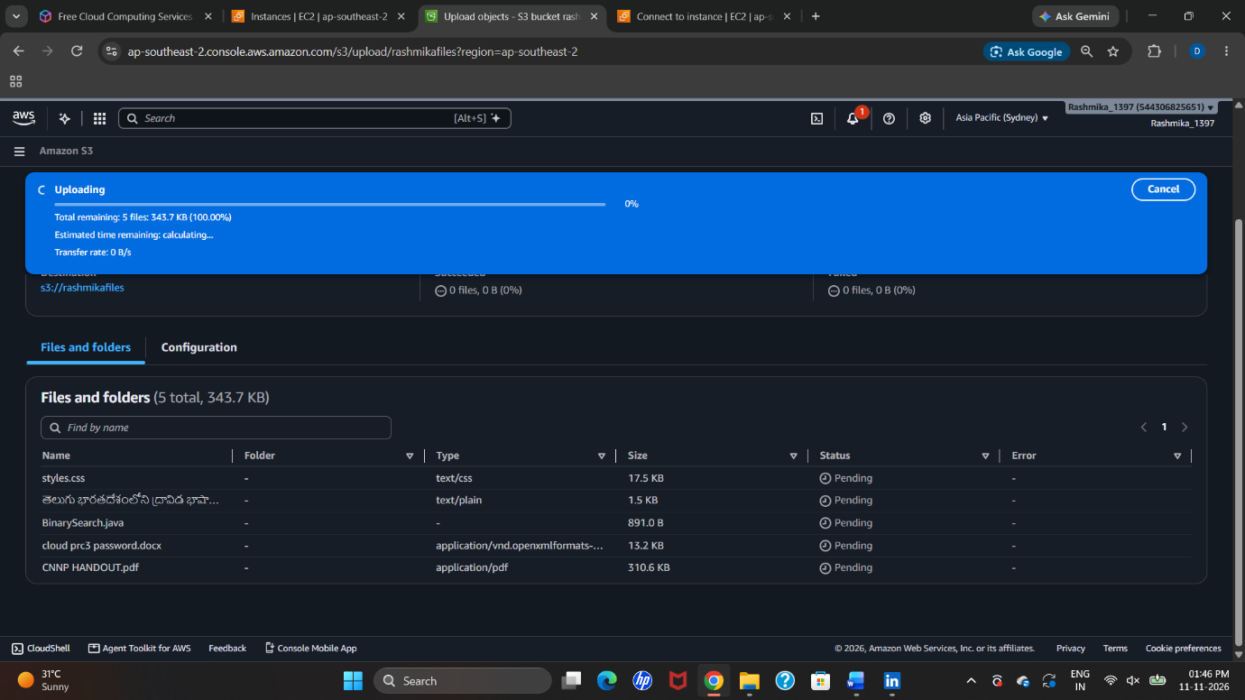

Step 7: Upload the objects
- Check that the destination is s3://rashmikafiles.
- Click Upload.
- Wait until the upload process finishes.
- The screenshot shows 5 files uploaded successfully, total size 343.7 KB, and 0 failed.
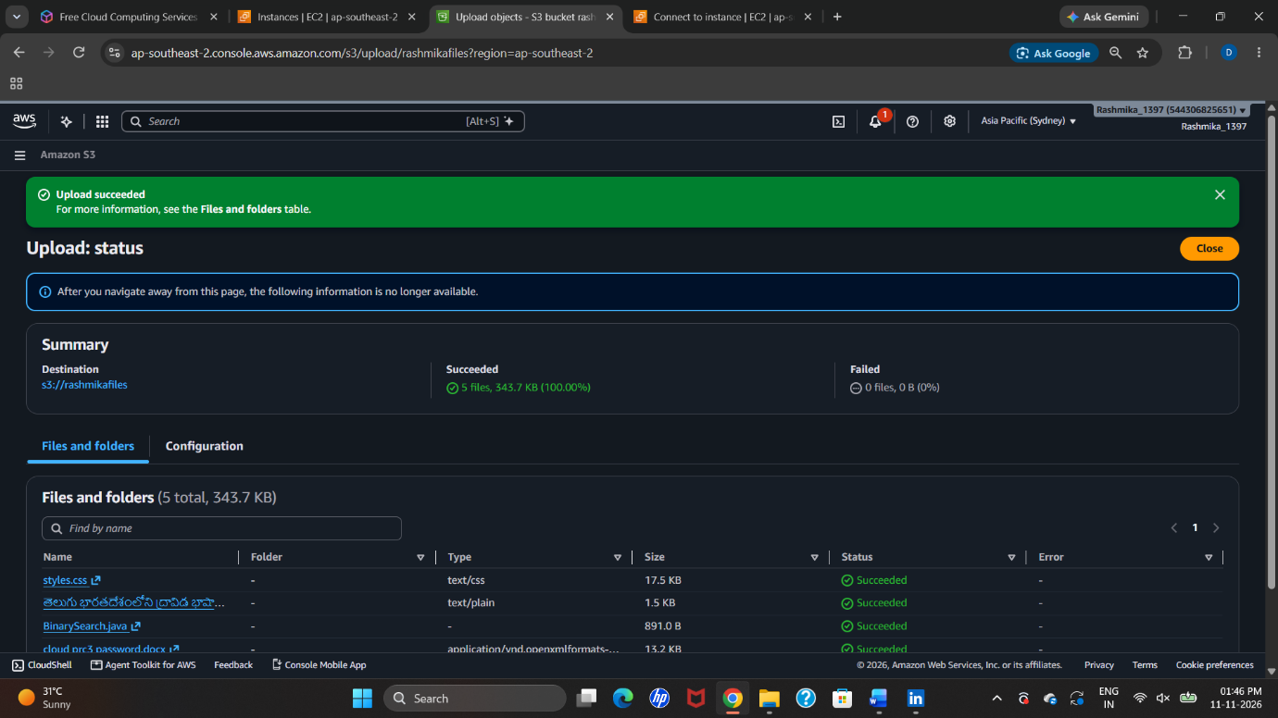

Step 8: Verify the uploaded objects
Close the upload status page and return to the bucket's Objects tab. Confirm that the five uploaded objects are listed in the bucket. This verifies that the files have been stored successfully in Amazon S3.

Step 9: Result
An Amazon S3 general-purpose bucket named rashmikafiles was created in the Asia Pacific (Sydney) region. Five objects with different file extensions (.css, .txt, .java, .docx, and .pdf) were uploaded successfully.

OVERALL RESULT
Successfully created and launched Amazon EC2 instances for Amazon Linux, Windows, and Ubuntu. Connected to the Linux instance through EC2 Instance Connect, accessed the Windows instance using Remote Desktop Protocol, and configured Ubuntu for remote desktop access using XFCE and XRDP. Also created an Amazon S3 bucket named rashmikafiles, uploaded five objects with different file extensions, and verified the successful upload.
Before finishing the lab, stop or terminate test EC2 instances that are no longer required and review AWS billing. Keep private keys and passwords secure.

